Unit test case-1

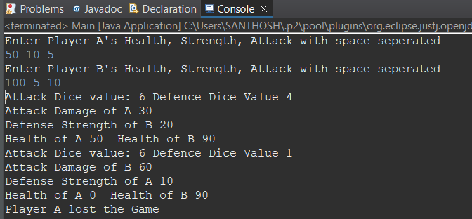

This image provides the relevant output based on the inputs given in the compiler it shows that player B won.

Unit test case-2

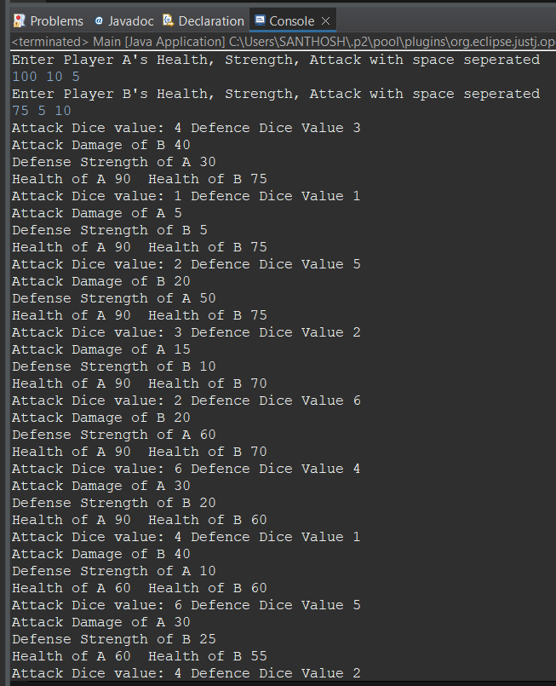

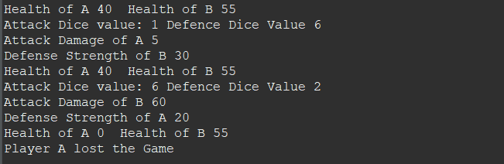

This image provides the relevant output based on the inputs given in the compiler it shows that player B won.

Unit test case-3

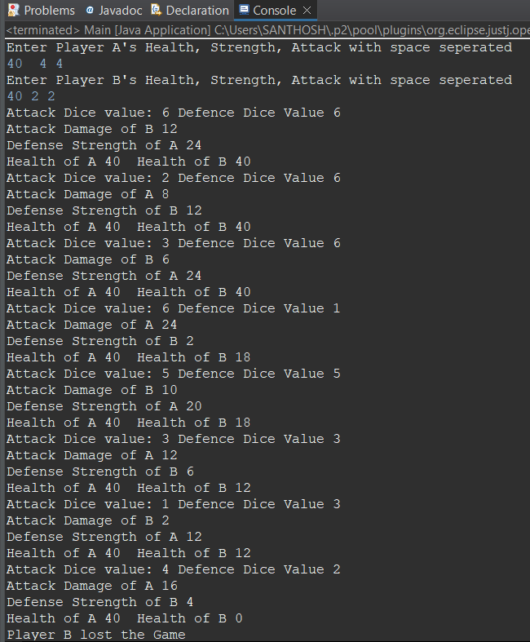

This image provides the relevant output based on the inputs given in the compiler it shows that player A won.